Formatting Group Names
The research group should be referred to as AETHER, or the AETHER Group. The AETHER Research Group is less acceptable, since it’s a bit redundant - AETHER stands for Advanced, Effective, Translational Health Engineering Research, so it would be an ATM machine situation.

When using the group’s name, it should be formatted in all caps - AETHER. All logos, websites, and digital assets should reflect this. Aether is not acceptable.

In some digital assets (namely where the condensed logo is used), AETHER may be simplified to just Æ. This is a specific use case - only when the condensed logo MUST be used can it be simplified to Æ in the logo. The group should never be referred to as the Æ Group in text, nor the ÆTHER group. Since the name is an acronym, the letters must be separated in text (we’re not the Ægis Translational Health Engineering Research Group, after all).

If you’re putting together assets with text, please do not use GenAI to write the text sections. The delicate nature of our research topics (AI and healthcare) is already an uphill battle to ensure that those interested in our work don’t get the impression that we’re feeding in sensitive patient information to LLMs, nor the idea that we’re fully replacing doctors. The implications of generating text for our outputs will torpedo our group’s credibility, which is something I’m sure we all want to avoid. If you’re struggling to write it on your own, please contact jnschofield1@sheffield.ac.uk, and I’ll help. This also goes for images - I’ve done the grunt work on constructing the logos, so if there’s another image you need that isn’t provided in the drive, let me know. If you want to take a stab at designing something yourself, see below for the required colour palettes, fonts, and other design choices. I use Photopea for my editing, which is a 1-to-1 recreation of Photoshop, and it’s excellent.

Colour Palettes:

Primary

Primary Colour: #2B075A

Primary Colour Tints:

80%: | 60%: | 40%: | 20%: | 5%:
#55397B | #806A9C | #AA9CBD | #D5CDDE | #F4F3F7

Primary Colour Shades:

80%: | 60%: | 40%: | 20%: | 5%:
#220648 | #1A0436 | #110324 | #090112 | #020005

Note: The primary colour is already very dark, so these shades are not recommended for common use, but are included for completeness.

Secondary

Secondary Colour: #1FB7EA

Secondary Colour Tints:

80%: | 60%: | 40%: | 20%: | 5%:
#4CC5EE | #79D4F2 | #A5E2F7 | #D2F1FB | #F4FBFE

Secondary Colour Shades:

80%: | 60%: | 40%: | 20%: | 5%:
#1992BB | #136E8C | #0C495E | #06252F | #02090C

Tertiary

Tertiary Colour: #06D6A0

Tertiary Colour Tints:

80%: | 60%: | 40%: | 20%: | 5%:
#38DEB3 | #6AE6C6 | #9BEFD9 | #CDF7EC | #F3FDFA

Tertiary Colour Shades:

80%: | 60%: | 40%: | 20%: | 5%:
#05AB80 | #048060 | #025640 | #012B20 | #000B08

Accent 1

Accent 1 Colour: #EF476F

Accent 1 Colour Tints:

80%: | 60%: | 40%: | 20%: | 5%:
#F26C8C | #F591A9 | #F9B5C5 | #FCDAE2 | #FEF6F8

Accent 1 Colour Shades:

80%: | 60%: | 40%: | 20%: | 5%:
#BF3959 | #8F2B43 | #601C2C | #300E16 | #0C0406

Accent 2

Accent 2 Colour: #FFD166

Accent 2 Colour Tints:

80%: | 60%: | 40%: | 20%: | 5%:
#FFDA85 | #FFE3A3 | #FFEDC2 | #FFF6E0 | #FFFDF7

Accent 2 Colour Shades:

80%: | 60%: | 40%: | 20%: | 5%:
#CCA752 | #997D3D | #665429 | #332A14 | #0D0A05

Accent 3

Accent 3 Colour: #F9591F

Accent 3 Colour Tints:

80%: | 60%: | 40%: | 20%: | 5%:
#FA7A4C | #FB9B79 | #FDBDA5 | #FEDED2 | #FFF7F4

Accent 3 Colour Shades:

80%: | 60%: | 40%: | 20%: | 5%:
#C74719 | #953513 | #64240C | #321206 | #0C0402

Full Colour Swatch

Colour Comparison:

#2B075A | #1FB7EA | #06D6A0 | #EF476F | #FFD166 | #F9591F

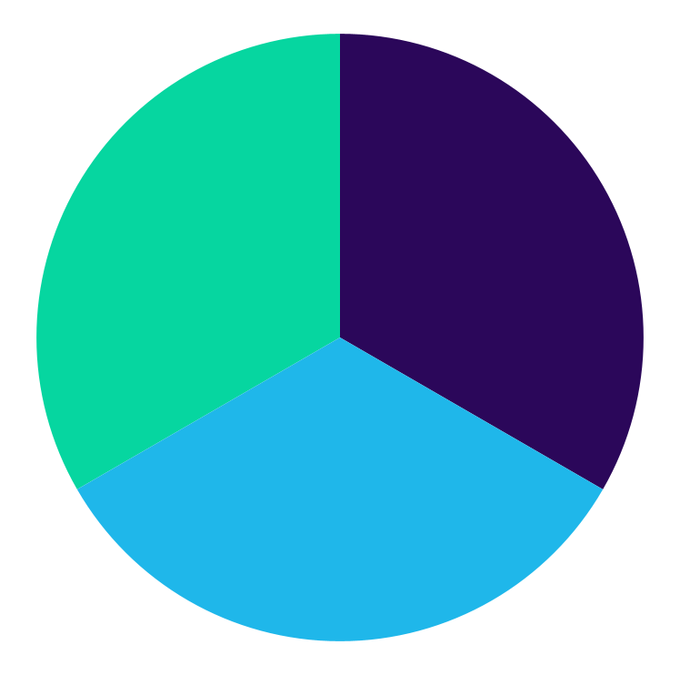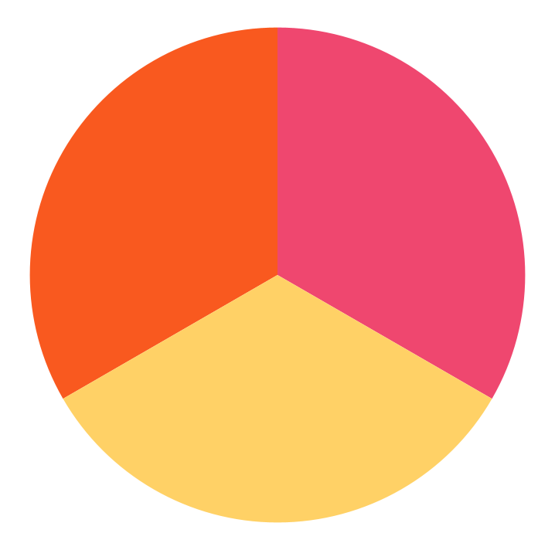



Usage

For general text, the 20% shade of the primary colour should be used.

For digital backgrounds, pure white can be very grating, therefore the 5% tint of the primary colour should be used.

The primary colour should be the main colour used for designing assets for AETHER, with secondary and tertiary being used to emphasise aspects of the design. When additional colours are required, the three accents may be used, but only after the initial colour trifecta has been used, such as for graphs or other illustrations.

In the unlikely case where additional shades or tints are required, they can be derived from this website: https://noeldelgado.github.io/shadowlord/

If there is a specific case that a design requires a tone (colour shifts towards grey) instead of a tint (colour shifts towards white) or shade (colour shifts towards black), please contact jnschofield1@sheffield.ac.uk to help achieve this.

Examples

This is black text on a white background.
This is 20% primary on 5% primary.

Fonts:

General Text:

Tahoma

The quick brown fox jumps over the lazy dog.
THE QUICK BROWN FOX JUMPS OVER THE LAZY DOG.
the quick brown fox jumps over the lazy dog.

Sphinx of black quartz, judge my vow.
SPHINX OF BLACK QUARTZ, JUDGE MY VOW.
sphinx of black quartz, judge my vow.

0123456789

AETHER
Æ

Headings:

Tahoma Bold
The quick brown fox jumps over the lazy dog.
THE QUICK BROWN FOX JUMPS OVER THE LAZY DOG.
the quick brown fox jumps over the lazy dog.

Sphinx of black quartz, judge my vow.
SPHINX OF BLACK QUARTZ, JUDGE MY VOW.
sphinx of black quartz, judge my vow.

0123456789

AETHER
Æ

Accessible Alternative Text:
OpenDyslexic:
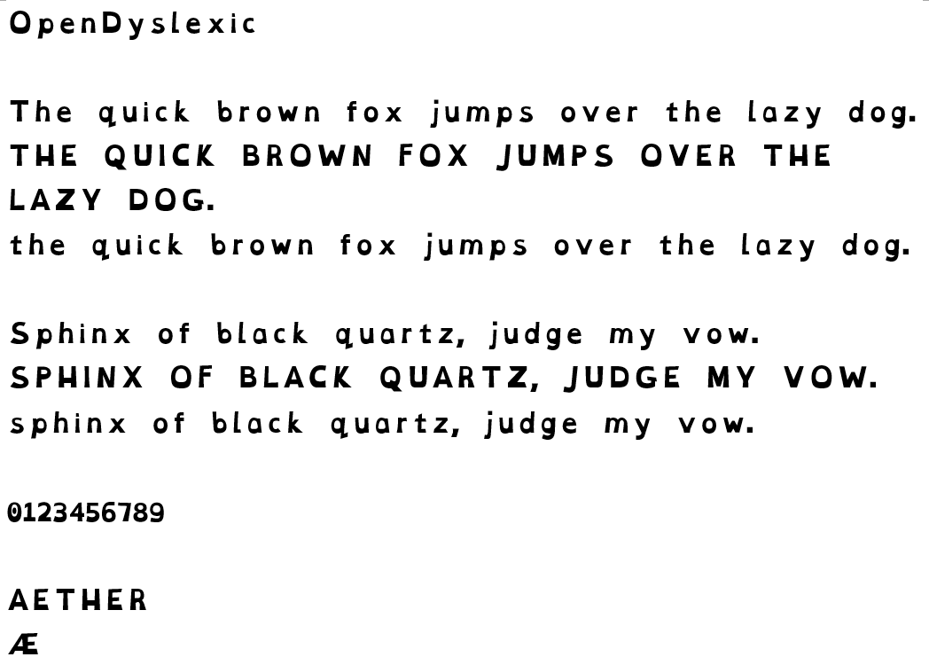

Accessibility:

If you are designing digital resources, please try to use true text functionalities for PDFs, allowing for compatibility with screen readers and personal accessibility tools. If this is not possible, try to make available a version of the document in OpenDyslexic font. The OpenDyslexic font can be downloaded from https://opendyslexic.org/, and helps to make resources more accessible to those with dyslexia or other language processing disorders.

If you are designing a website, please ensure that the style sheet allows for swapping to OpenDyslexic without any degradation in formatting. Please also make use of the Web Content Accessibility Guidelines (WCAG) from the World Wide Web Consortium to ensure that the website is accessible to all.

Before combining any colours for legibility, please check their contrast using the EightShapes Contrast Grid. The comparison between all tints/shades of all the colours has been made, and can be found here.

Any issues implementing these factors, please contact jnschofield1@sheffield.ac.uk.

Logos:

AETHER has a main logo and a few variations, with specific usages. Each version has colour variants, but as often as possible, the primary logo colour scheme should be used. All the raw logo images are available in Google Drive, in the “Logos” folder. Each variant will have standard sizes of PNGs, but also the SVG file for better scaling. If there’s a colour combination you require, but doesn’t yet exist, please let me know, and I can put it together. Currently included are reasonable light/dark versions of the primary colour scheme, as well as base versions of the secondary and tertiary colour schemes, and greyscale versions. If you notice an issue with the logo (fuzzing around shapes on different backgrounds, please let me know, and I can fix it accordingly.

Main Logo:


Condensed Logo:


Expanded Logo:



